Day 2: Overview of LMI Tools & Resources
May 4, 2021, 2:00 - 3:30 p.m.

Resource name | Pros | Cons | Remember to go back and explore...
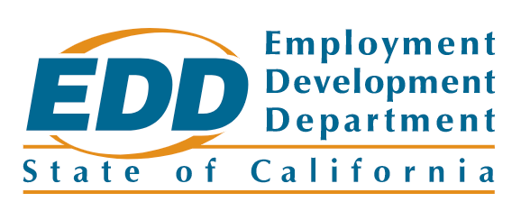
labormarketinfo.edd.ca.gov


bls.gov
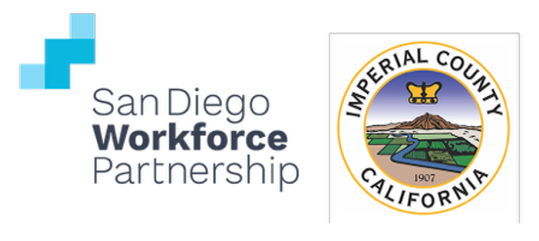
workforce.org/careercoach

cacareerzone.org

caljobs.ca.gov

onetonline.org
Sources for Reports & Articles
Resource name | Notes |  | Link to go back and read

economicmodeling.com/research

burning-glass.com/research

investinwork.org

oecd.org/employment

